**SRM Institute of Science and Technology, Tiruchirappalli Campus**

**Faculty of Engineering and Technology**

**Department of Electronics and Communication Engineering**

**Assignment - I**

**24.08.2023**

**Submission date :** 30.08.2023

**Assignment Marks :** 10

**Rubrics :**

1. Problem solving : 05 marks
2. Presentation : 05 marks
3. Obtain the output waveform for the given circuit

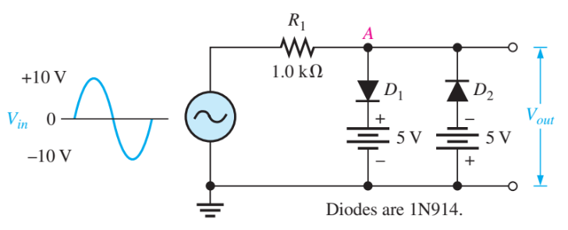

1. An HWR has a load of 3.5 kW. If the diode resistance and secondary coil resistance together have a resistance of 800 Ω and the input voltage has a signal voltage of peak value 240 V. Calculate

(a) peak, average and rms values of current flowing

(b) dc power output

(c) ac power input

(d) efficiency of the rectifier

1. A full-wave rectifier delivers 50 W to a load of 200 W. If the ripple factor is 1%, calculate the ac ripple voltage across the load.
2. A voltage of 200 cos ⍵t is applied to HWR with load resistance of 5 kW. Find (a) the maximum dc current component, (b) rms current, (c) ripple factor, (d) TUF, and (e) rectifier efficiency